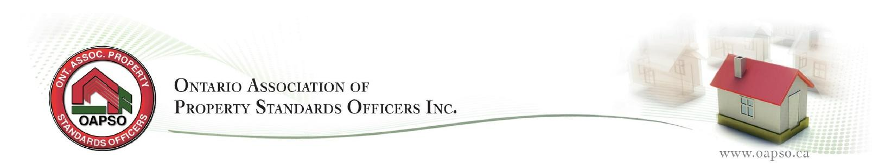

2022 Part 4 Agenda

 | Monday May 16 | Tuesday May 17 | Wednesday May 18
9:00 – 10:15 am | DOLA | Unsafe Buildings | AMPS for Property Standards
 | Paul Dray | Gerald Moore  RSM Building | Shayne Turner
10:45 – 12:00pm | DOLA | Unsafe Buildings | Managing Stress and Burnout
 | Paul Dray | Gerald Moore  RSM Building | Jenna Rachiele  Master Life Coach
12-1:00 pm | Lunch | Lunch | Lunch
1:00- 2:15 pm | TBD | Preparing for a Promotion | AGM
 |  | Jim Bird
2:45- 4:00pm | TBD | Preparing for a Promotion | AGM
 |  | Jim Bird

-

